# Use Case Diagram:

## Level 0:

**Name:** Library Management System (LMS)

**Primary Actor:** User (Student, Teacher, Staff), Librarian

**Secondary Actor:** Book Purchase Committee (BPC), Mobile Financial Services (MFS), OTP System, Email System

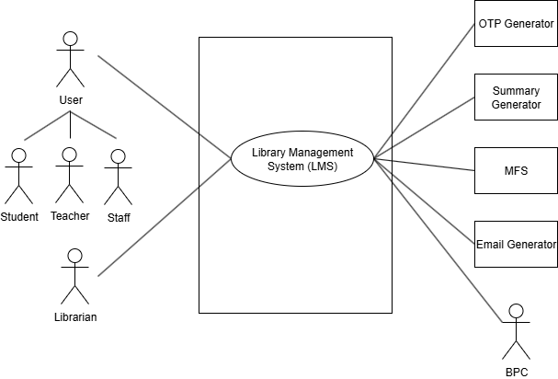

## Level 1:

**Name:** Library Management System (LMS)

**Primary Actor:** User (Student, Teacher, Staff), Librarian

**Secondary Actor:** Book Purchase Committee (BPC), Mobile Financial Services (MFS), OTP, Email System

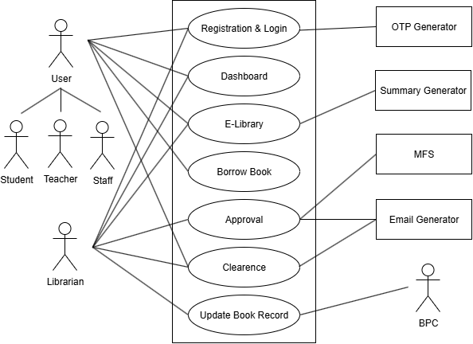

## Level 1.1:

**Name:** Registration & Login

**Primary Actors:** User (Student, Teacher, Staff), Librarian  
**Secondary Actors:** OTP System

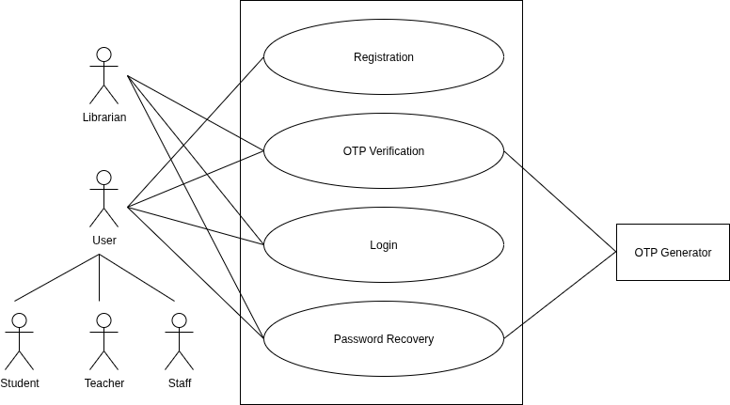

## Level 1.2:

**Name:** Dashboard

**Primary Actors:** User (Student, Teacher, Staff), Librarian

## Level 1.3:

**Name:** E-Library

**Primary Actors:** User (Student, Teacher, Staff), Librarian

**Secondary Actors:** Summary Generator

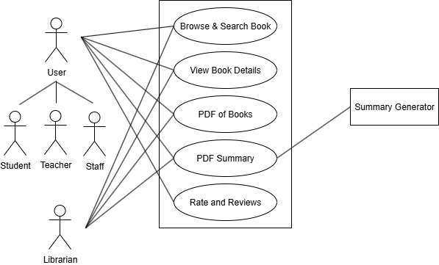

## Level 1.4:

**Name:** Borrow Book

**Primary Actors:** User (Student, Teacher, Staff)

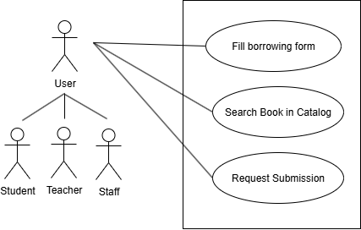

## Level 1.5:

**Name:** Approval

**Primary Actors:** Librarian

**Secondary Actors:** Email Generator, MFS

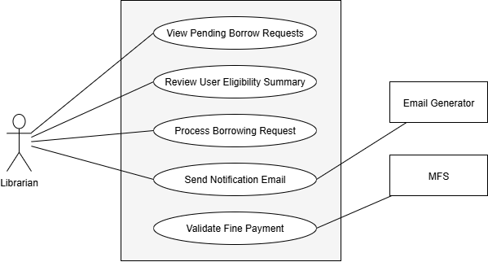

## Level 1.6:

**Name:** Clearance

**Primary Actors:** User (Student, Teacher, Staff), Librarian

**Secondary Actors:** Email Generator

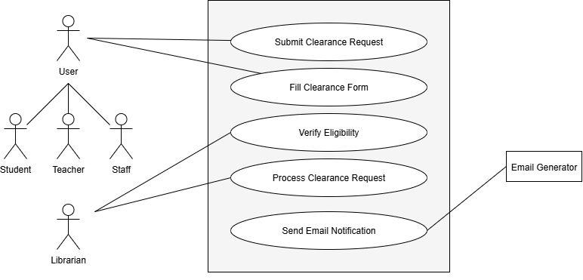

## Level 1.7:

**Name:** Update Book Record

**Primary Actors:** Librarian

**Secondary Actors:** BPC

